Create Table snaps
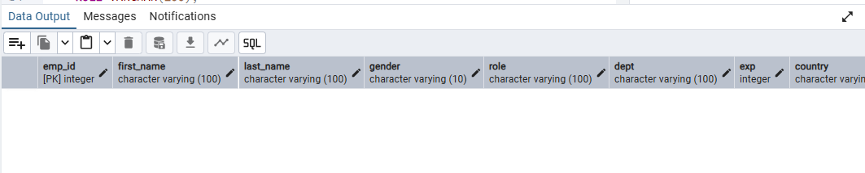
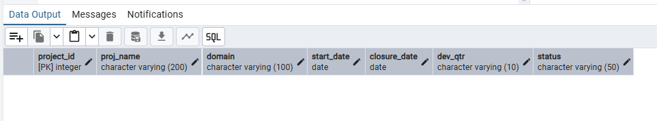
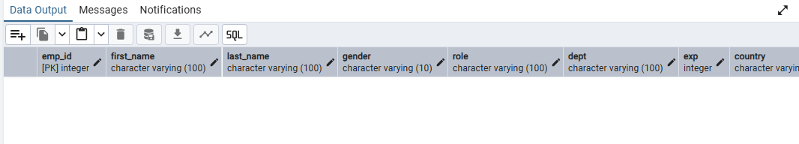

emp_record_table snap – CSV file uploaded successfully
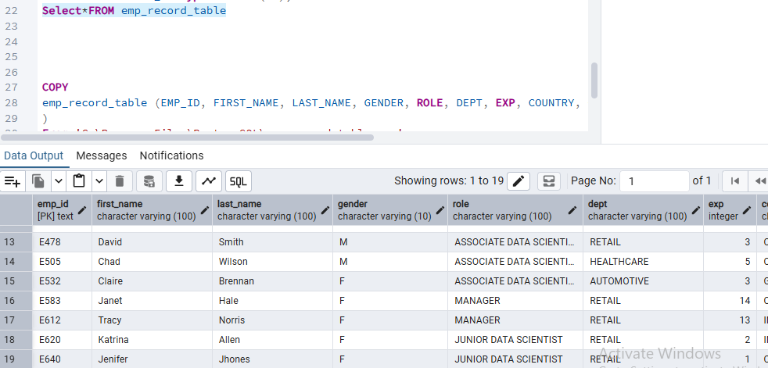

Proj_table snap – CSV file uploaded successfully

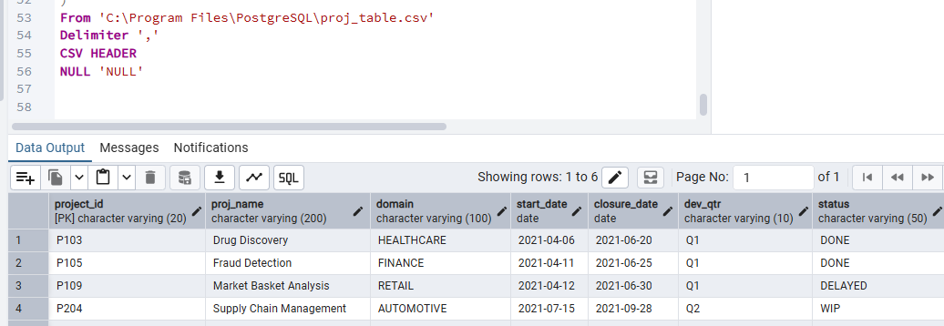
Data_science_team snap – CSV file uploaded successfully
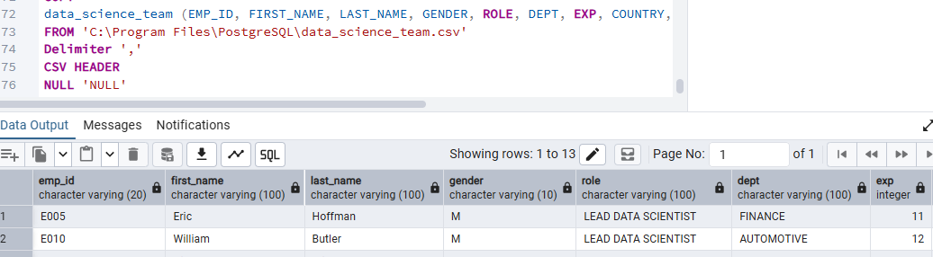

2. Write a query to fetch EMP_ID, FIRST_NAME, LAST_NAME, GENDER, and DEPARTMENT from the employee record table, and make a list of employees and details of their department

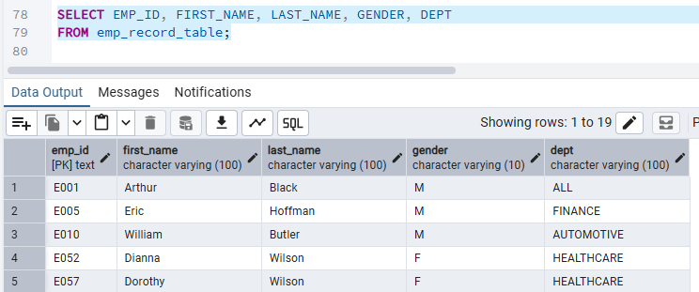
3. Write a query to fetch EMP_ID, FIRST_NAME, LAST_NAME, GENDER, DEPARTMENT, and EMP_RATING if the EMP_RATING is: ● less than two ● between two and four ● greater than four
Less than two
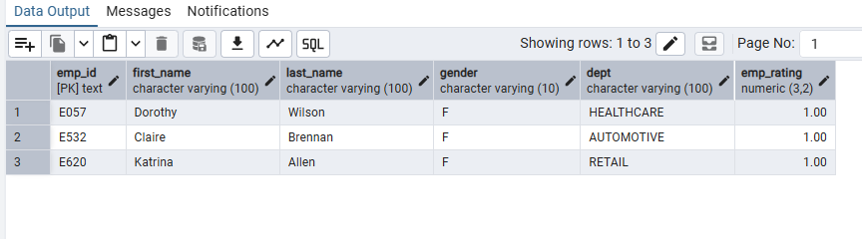between two and four
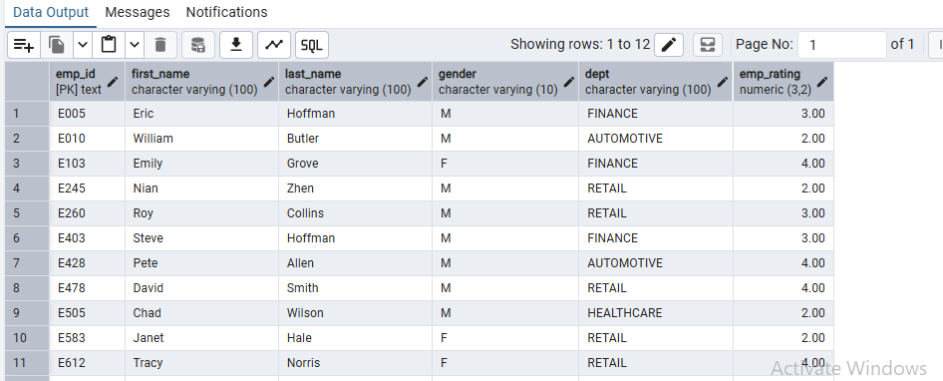
greater than four
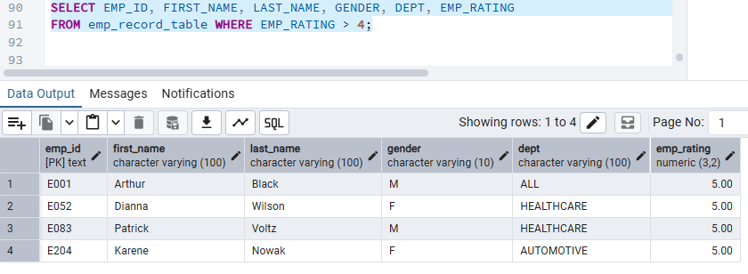

4. Write a SQL query to retrieve the employee ID, first name, role, and department of employees who hold leadership positions (Manager, President, or CEO)
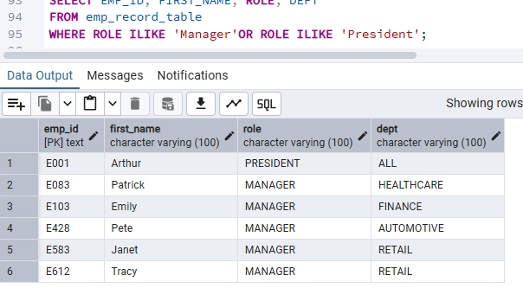
5. Write a query to list employee details, including EMP_ID, FIRST_NAME, LAST_NAME, ROLE, DEPARTMENT, and EMP_RATING, grouped by department. Also include the respective employee rating along with the max emp rating for the department
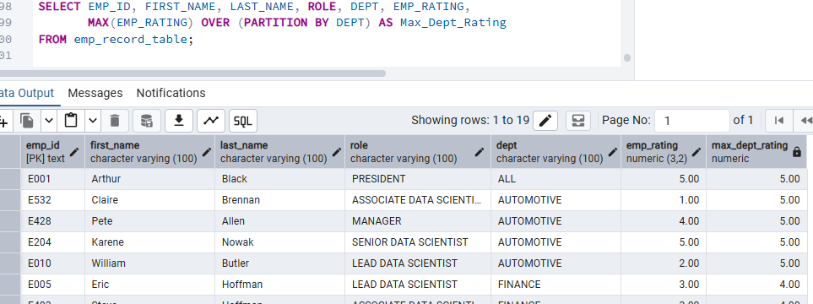

6. Write a query to find the minimum and maximum salary for employees grouped by their role, using data from the employee record table

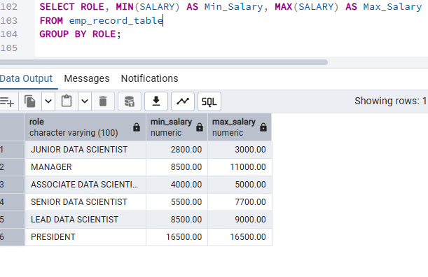
7. Write a query to assign a rank to each employee based on their years of experience, using data from the employee record table

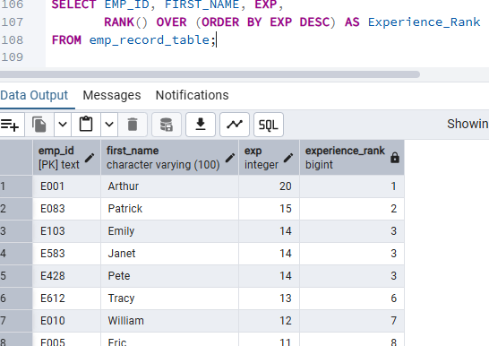

8. Write a query to create a view that displays employees in various countries whose salary is more than six thousand, using data from the employee record table
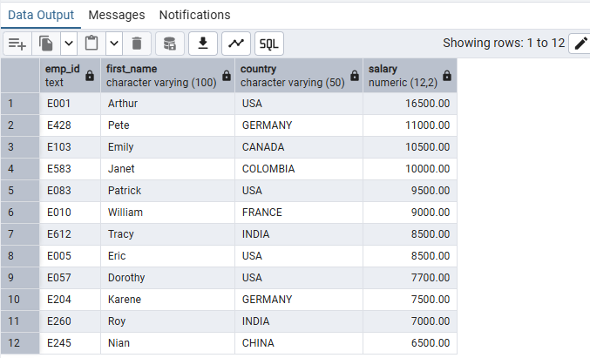

9. Write a query to create a view that lists employees across different countries who earn a salary greater than 6000, using data from the employee record table


10. Create an index to improve the cost and performance of the query to find the employee whose FIRST_NAME is Eric in the employee table, after checking the execution plan

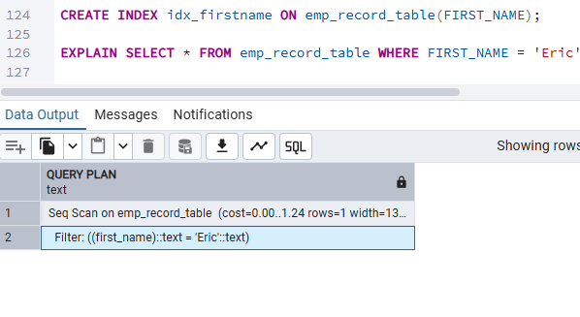
11.Write a query to calculate the average salary distribution based on the continent and country. Take data from the employee record table

